**AWS CloudFront Signed URL using Cloud shell**

CloudFront signed URLs provide a mechanism to control access to the content served through a distribution. Example: You have uploaded company Design Images contents in S3. After uploaded my users from your company started using the contents from the S3. There is one requirement from your manager only specific user are able to access those contents from S3 with specific time duration. To achieve this, we going to use CloudFront with Signed URL.

Go to Security Credential user your login name

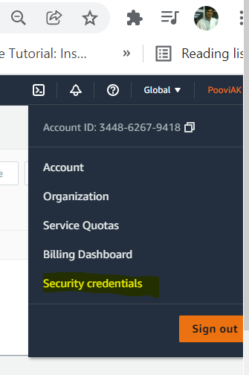

Create new keypair

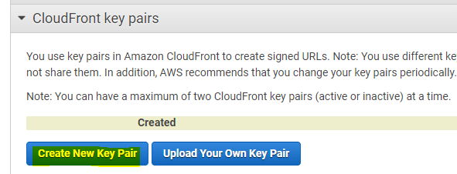

Download both public and private key

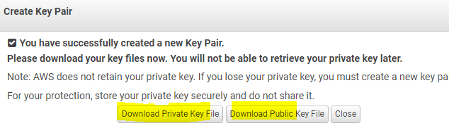

Both key are created and downloaded and you can see the access ID.

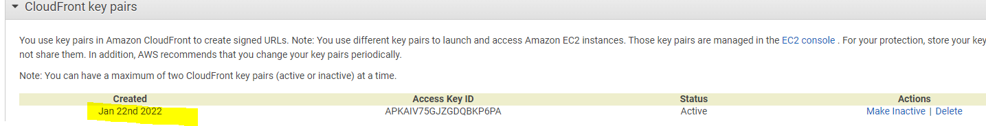

Now switch to cloud shell. Create a file with private key name and paste the content from private key here.

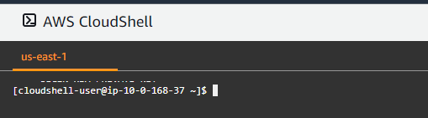

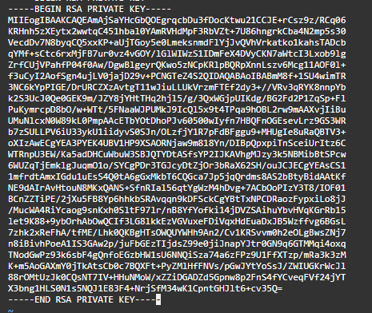

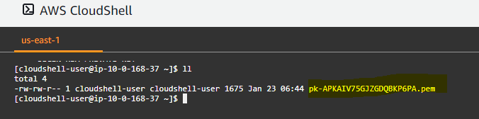

Use below format command to create signed URL and this URL is valid till 22nd Jan 2022 next day it will expire.



aws cloudfront sign --url https://d2uib3bfa3tnya.cloudfront.net/index2.html --key-pair-id APKAIV75GJZGDQBKP6PA --private-key file://pk-APKAIV75GJZGDQBKP6PA.pem --date-less-than 2022-01-22

**Command explanation**

sign 🡪 you have to give cloudfront

URL 🡪 give cloudfront distribution url

Keypair 🡪 give Access key ID which is created in security creadential.

Private-key 🡪 specify the private key located path

Date-less-than 🡪 mention the time duration for the URL

Now access the URL in the browser.

